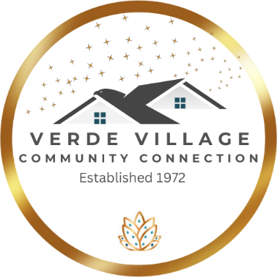

MINUTES
of the
November 14th, 2023 GENERAL MEMBERSHIP MEETING
of
VERDE VILLAGE PROPERTY OWNERS’ ASSOCIATION
a nonprofit corporation

Directors in attendance and constituting a quorum were:
Aislinn Maldonado, Jeff Raible, Jessica L Walczak, David Hoover, Sarah White, & Sylvia Yost

Directors Absent:
Brad Sutton, Tia (Sylvia) Martinez, Wendy McCants, Daniel Maldonado, Cheryl Kasdorf, & Cathy Foley

Procedural Notes:
Aislinn started meeting at 7:03pm

Dave made a motion for approval of the October General meeting minutes, Jeff 2nd however motion was upheld due to needing to correct meeting minutes for Nature preserve to remove verbiage and to add removal of invasive species.

Treasure Report:
Copy of the Treasurer Report was issued for the month of October and Jeff reported that income was essentially the same as expenses for October. Of particular interest are grey boxes on the report which note that Bingo-related income amounts (food purchase and
play fees) were adjusted after a detailed audit, but there was no change to the total aggregate Bingo income. Core Operations year-to-date, we are about $10,500 to the good. The report was already approved by the board at the October board meeting.

Membership:
Jeff reported 11 memberships this month and November is always a slow month for memberships.

Highway Cleanup:
Aislinn reported HWY cleanup is on November 18 starting at 8 am and meet at the Gateway Church, Mal leads the group

Upcoming events:
- Community Survey, how can we serve you, we are on Next door, Facebook page our website
- Youth Fishing Tournament 11/18
- Night of worship, non-denominational on 11/24
- General meeting 12/12 7pm there will be ugly sweater/cooking exchange
- White elephant party 12/16 nothing more than $20, or gift from house
- Night of worship on 12/29

Q & A
Question regarding pond, did we get the ok and money for the well? Discussion and educated that board will be looking at all options for the pond after the holidays, cottonwood ditch will shut off water in 2026, met with fire department. Also discussed with putting in a well issue is can the well support the entire pond and 2nd issue is water rights are being challenged, salt river projects has claimed our water rights and all ponds in Cottonwood may need to be shut off if used for recreational use, there is a lot of conversations that need to happen, and when board starts to discuss the pond Sarah will be sending out letters to the residents that live by the pond as to what is happening and needing volunteers to assist.
Also, to clarify that the Night of Worship is put on by an outside organization and not the VVCC, someone rents the clubhouse for event.
Dave made a motion to adjourn the meeting, Jeff 2nd, Unanimously voted
Meeting ended at 19:33.
13 people attended the meeting
Meeting minutes were taken by
Jessica L Walczak, Secretary

